Aibo Wireless Setup for Robotics Lab

1. Set up WLANCONF.TXT

#
# WLAN
#
HOSTNAME=AIBO<X>
ESSID=LTU Wireless Network
WEPENABLE=0
#WEPKEY=AIBO2
APMODE=1

#
# IP network
#
USE_DHCP=1
#
# If DHCP is not used (USE_DHCP=0), you need to specify IP
# network configuration.
#
#USE_DHCP=0
#ETHER_IP=192.168.0.2
#ETHER_NETMASK=255.255.255.0
#IP_GATEWAY=192.168.0.1
#DNS_SERVER_1=0.0.0.0

#
# SSDP
#
SSDP_ENABLE=1

2. Place on Aibo with desired program (stick image) and boot.
3. Find IP address
Goto http://192.168.0.1
ID admin
PW password

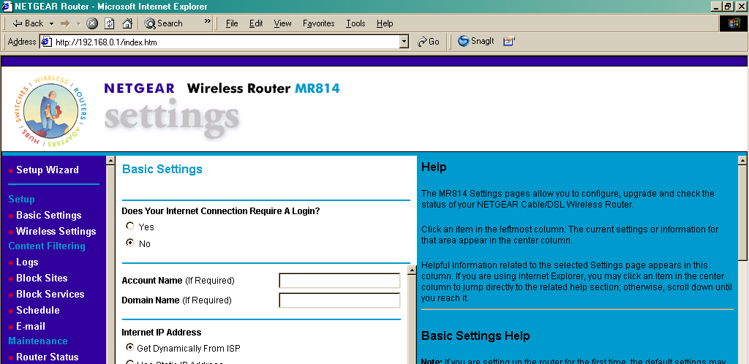

Click on Attached Devices, The Aibo device name is blank.
