Course Number: MCS4833
Section Number: 01
Course Name: Senior Project
Instructor: Prof. Chung
Date: 11-1-00

SPECIFICATIONS – SENIOR PROJECT OF JOHN NEWMAN

One of the program’s purposes is to facilitate research regarding which variables are having the most significant effect on patient progress and to report numerical facts about the population receiving treatment from M.O.R.C. to the County Mental Health Boards.
The input for the application will be:
- Scores of psychiatric patient symptom scales that will be processed with multivariate analysis. The psychiatric symptom scales that will be incorporated into the program are those of the Brief Psychiatric Rating Scale, a widely accepted measure of severe psychiatric symptoms utilized for diagnosis. The completed rating scales will be entered into the application by the secretary to the Director of Psychiatric Services of Macomb Oakland Regional Center, Inc. (M.O.R.C.)
- The names of the medications and the dosages that the person is taking at the time that the rating scales are completed.
- The program will record additional input in the form of the type of residential staff intervention, the type of day program rehabilitation, the number of hours of clinical and non-clinical staff intervention, and the extent to which the person’s symptoms interfere with her/his basic self-care, work or school.
- It will record whether or not the psychiatric symptoms prohibit independent access to the community.
- It will record whether or not the person’s interpersonal interactions are affected as input.
- It will record the person’s physical problems, as well as the psychiatric symptoms, and whether the physical problems are interfering with the person’s functioning in the community at the time of the psychiatric symptom evaluation.

Clinicians record these factors 2 – 6 above along with the symptom scales and submit them to the Secretary to the Director of Psychiatry. The application captures the state of these factors at the time that the psychiatric symptom scales are completed. A series of these “snapshots” are recorded over time. The program will allow the Director of Psychiatry to evaluate person’s progress or regression from one measurement to another.
The application will facilitate the Director of Psychiatry in determining which factors affected progress.

Another purpose of the application is to provide uniform, accurate diagnosing of patients
by all psychiatrists, clinical social workers, and psychologists who work for the company.
Therefore, the other output of the application will be a psychiatric diagnosis for each patient.

Summary of Output:
- Numerical population facts
- Psychiatric diagnosis

Please see workflow diagram below:

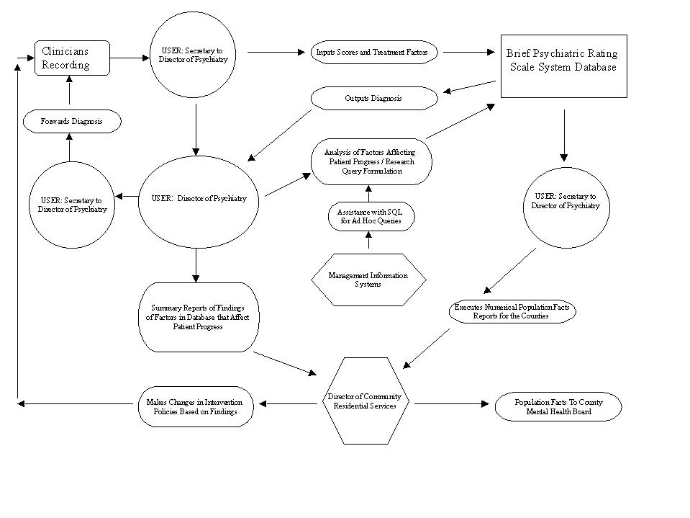
WORKFLOW DIAGRAM - BRIEF PSYCHIATRIC RATING SCALE SYSTEM
DATABASE

